Stowarzyszenie Inicjatyw Kulturalno Młodzieżowych Art
"Switch To a Bike. Protect Your Home"
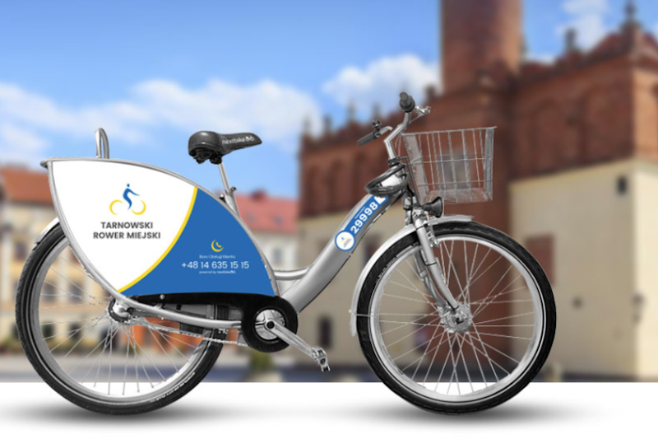
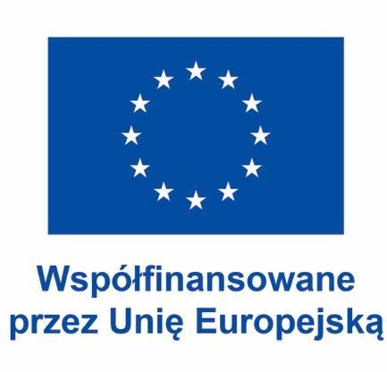
Wierzchosławice 22-29.05.2023
GREEN PRACTICES IN EUROPEAN CITIES TRANSPORT COMPANIES
INTRODUCTION
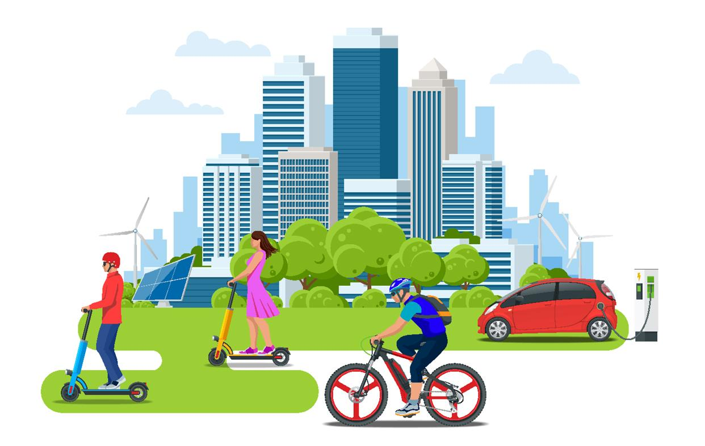
Transport currently accounts for a quarter of the EU's greenhouse gas emissions.
The European Commission proposed policies and initiatives with the goal of making Europe the world's first climate-neutral continent by 2050. A key objective is to boost considerably the uptake of clean vehicles and alternative fuels.
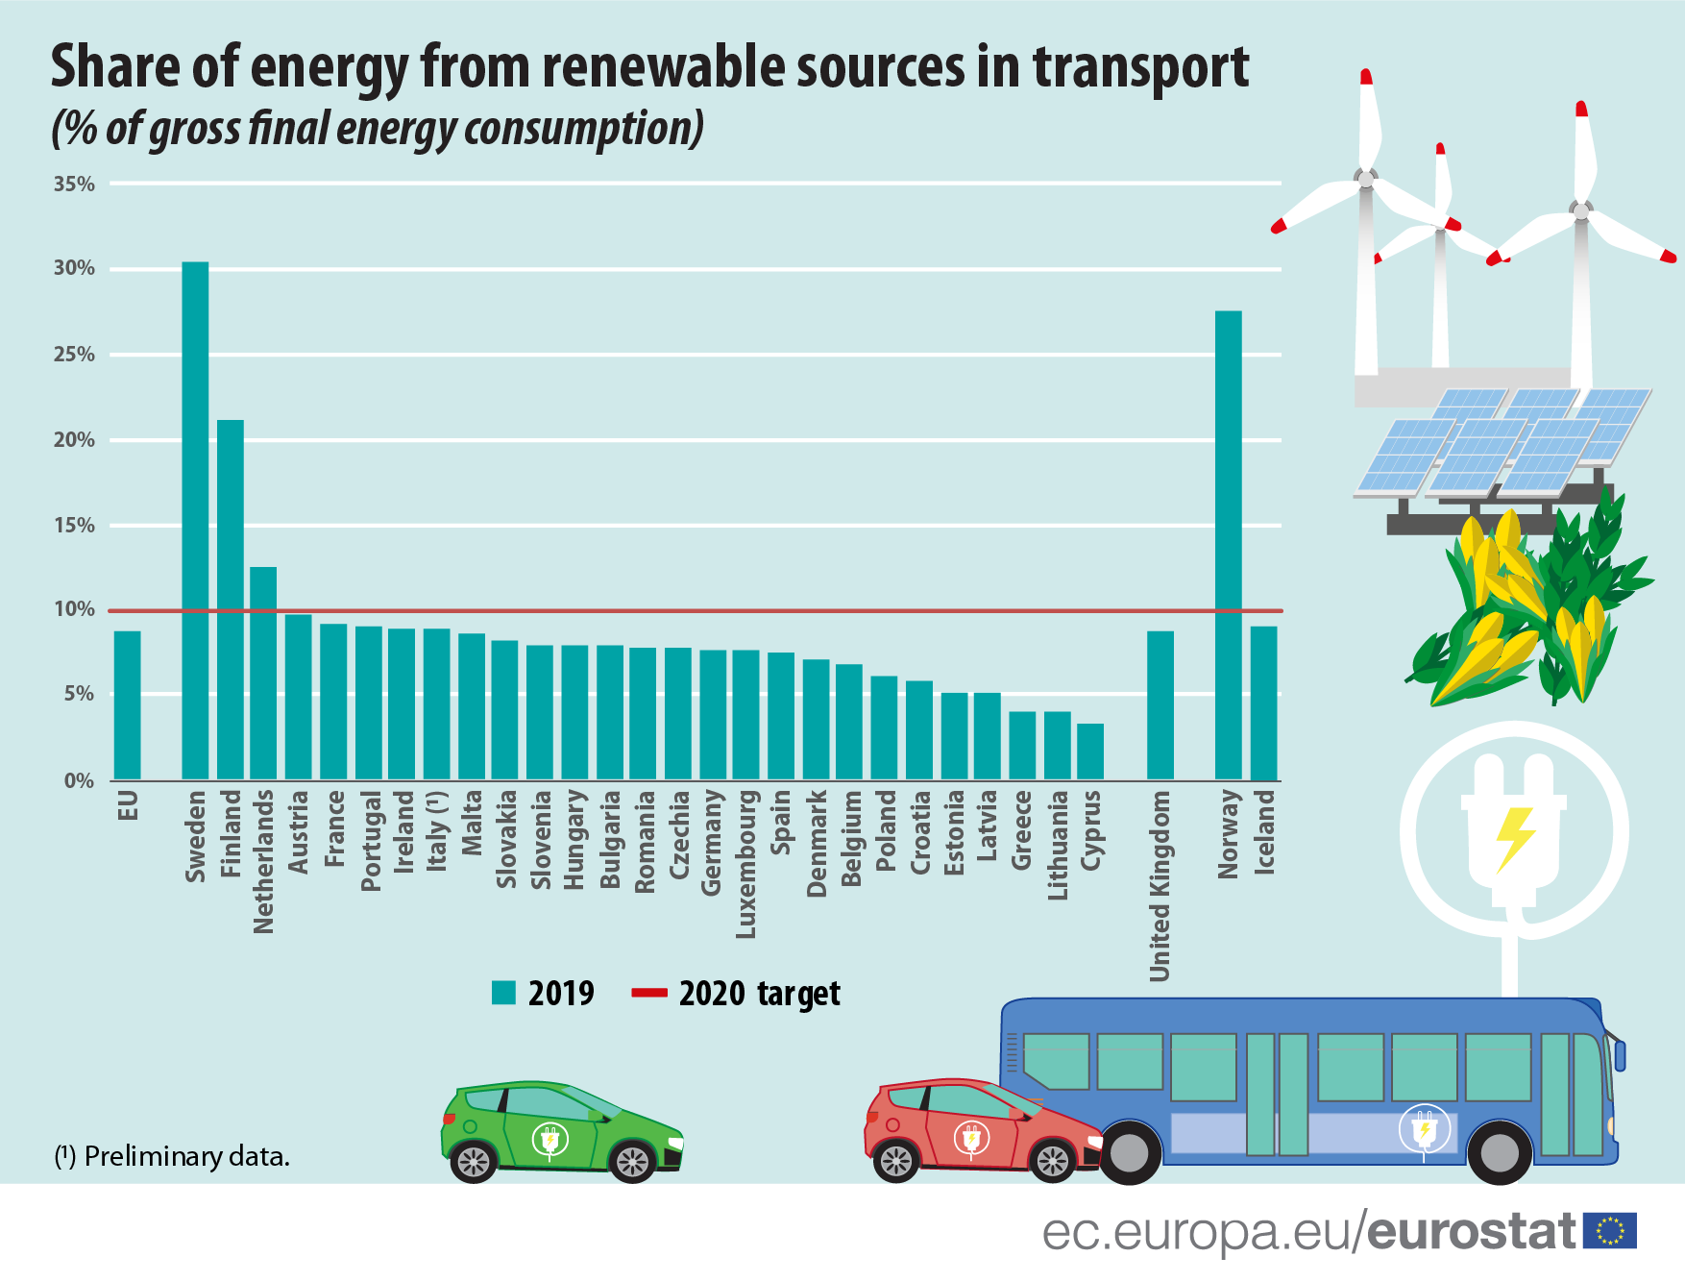
Among the EU Member States, the share of renewable energy in transport fuel consumption ranged from highs of 30.3% in Sweden, 21.3% in Finland and down to 4% or less in Greece and Lithuania (both 4.0%).
"Greening Transportation: Strategies for a Sustainable and Eco-Friendly Future"
1. Electrification: This reduces reliance on fossil fuels and decreases greenhouse gas emissions.
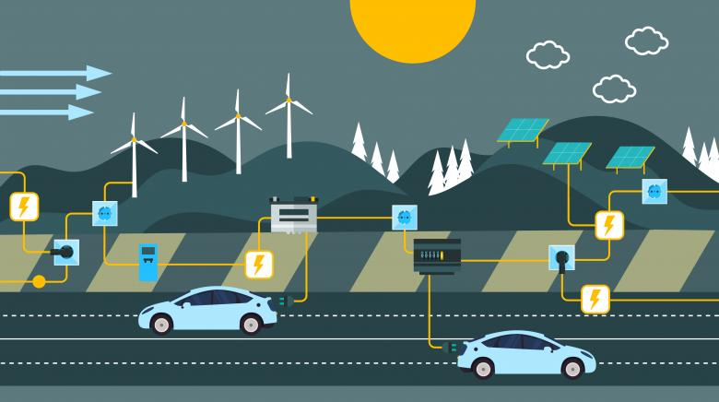
Electric vehicles (EVs) reduces greenhouse gas emissions, air pollution, and dependence on non-renewable energy sources.
2. Alternative fuels: Encourage the use of alternative fuels such as biofuels, hydrogen, and renewable natural gas.
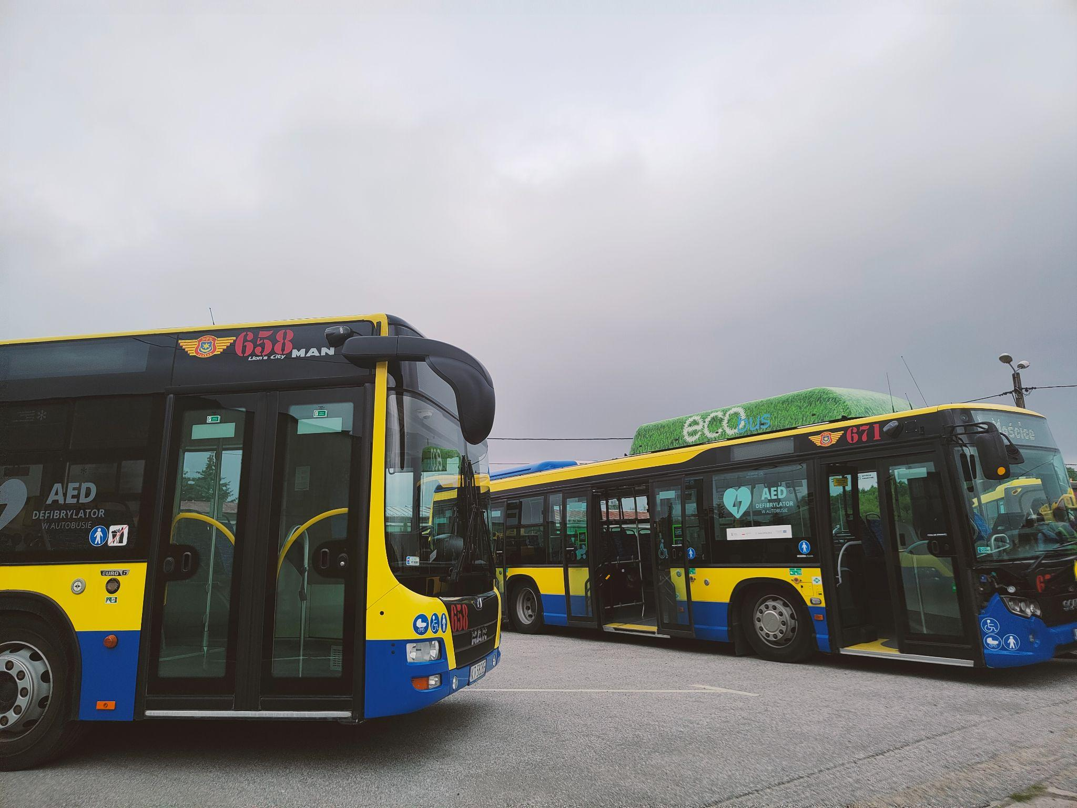
Zero Emissions: When used in a fuel cell vehicle, hydrogen combines with oxygen from the air to produce electricity, generating only water vapor as a byproduct.

3. Public transport and active mobility: Invest in and prioritize the development of efficient and accessible public transportation systems, including buses, trams, and trains. Promote walking, cycling.
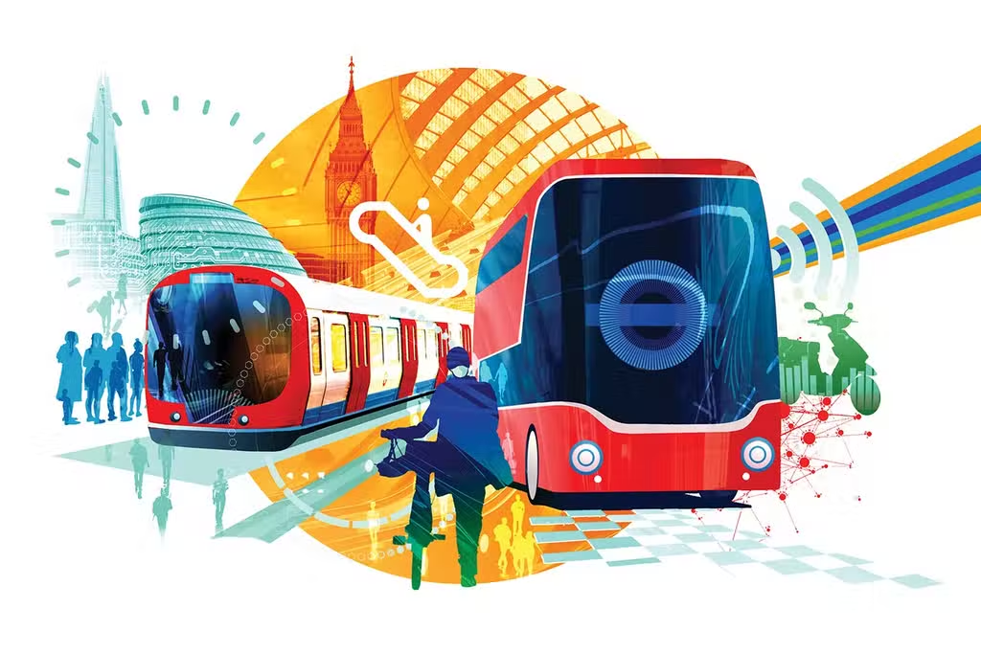
4. Efficient urban planning: Design cities and communities in a way that supports sustainable transportation. This includes providing dedicated cycling lanes.
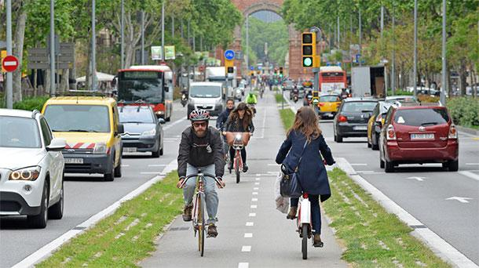
7. Infrastructure development: Invest in charging stations for electric vehicles, develop a network of refueling stations for alternative fuels.
8. Research and innovation: Support research and development initiatives to advance green transportation technologies.
- Research can focus on developing bio-based materials for battery components

Transportation examples/practices

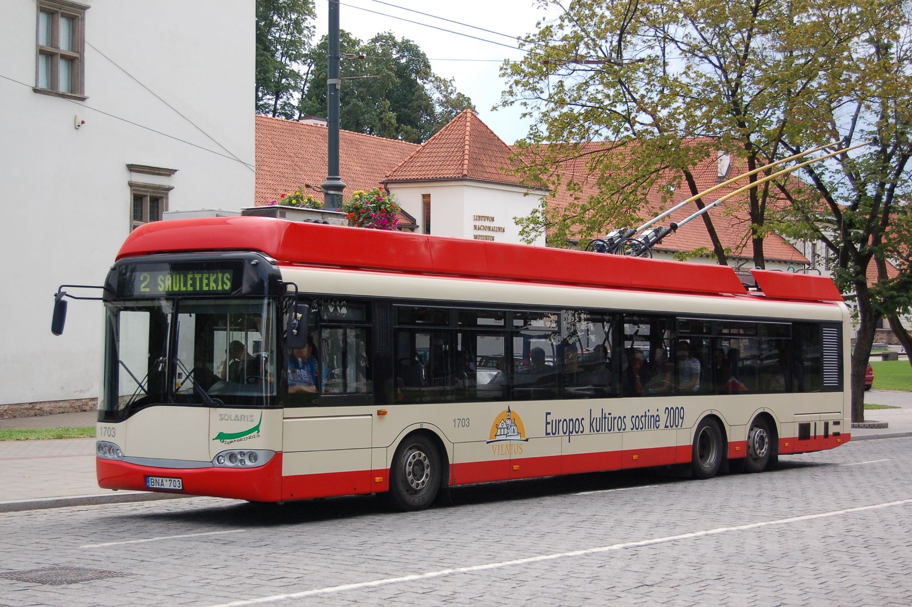
Trolley buses

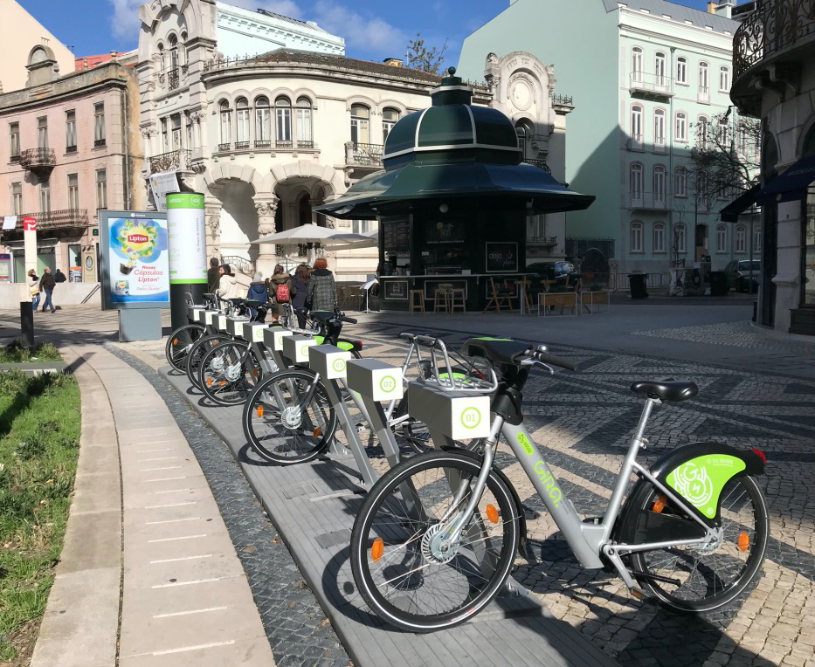
Electric bicycles and scooters - Bicycle sharing programs

Although having more variety of ecological transportation is important, for them to be relevant they need to have a public. This can be done through Government policies that incentivize collective and eco transportation, while creating some obstacles to more polluting and individualistic transportation methods. Some examples are:

- Government programs incentivizing/subsidizing electric vehicles and bicycles;
- Infrastructure development to promote more walkable/cyclable cities (i.e. Netherlands);
- Create integrated public transportation systems (i.e. Prague/Budapest/Bratislava);
- Free public transportation (Luxembourg);
- Create inconveniences for car usage (taxes, travel limitations);

Company examples/practices

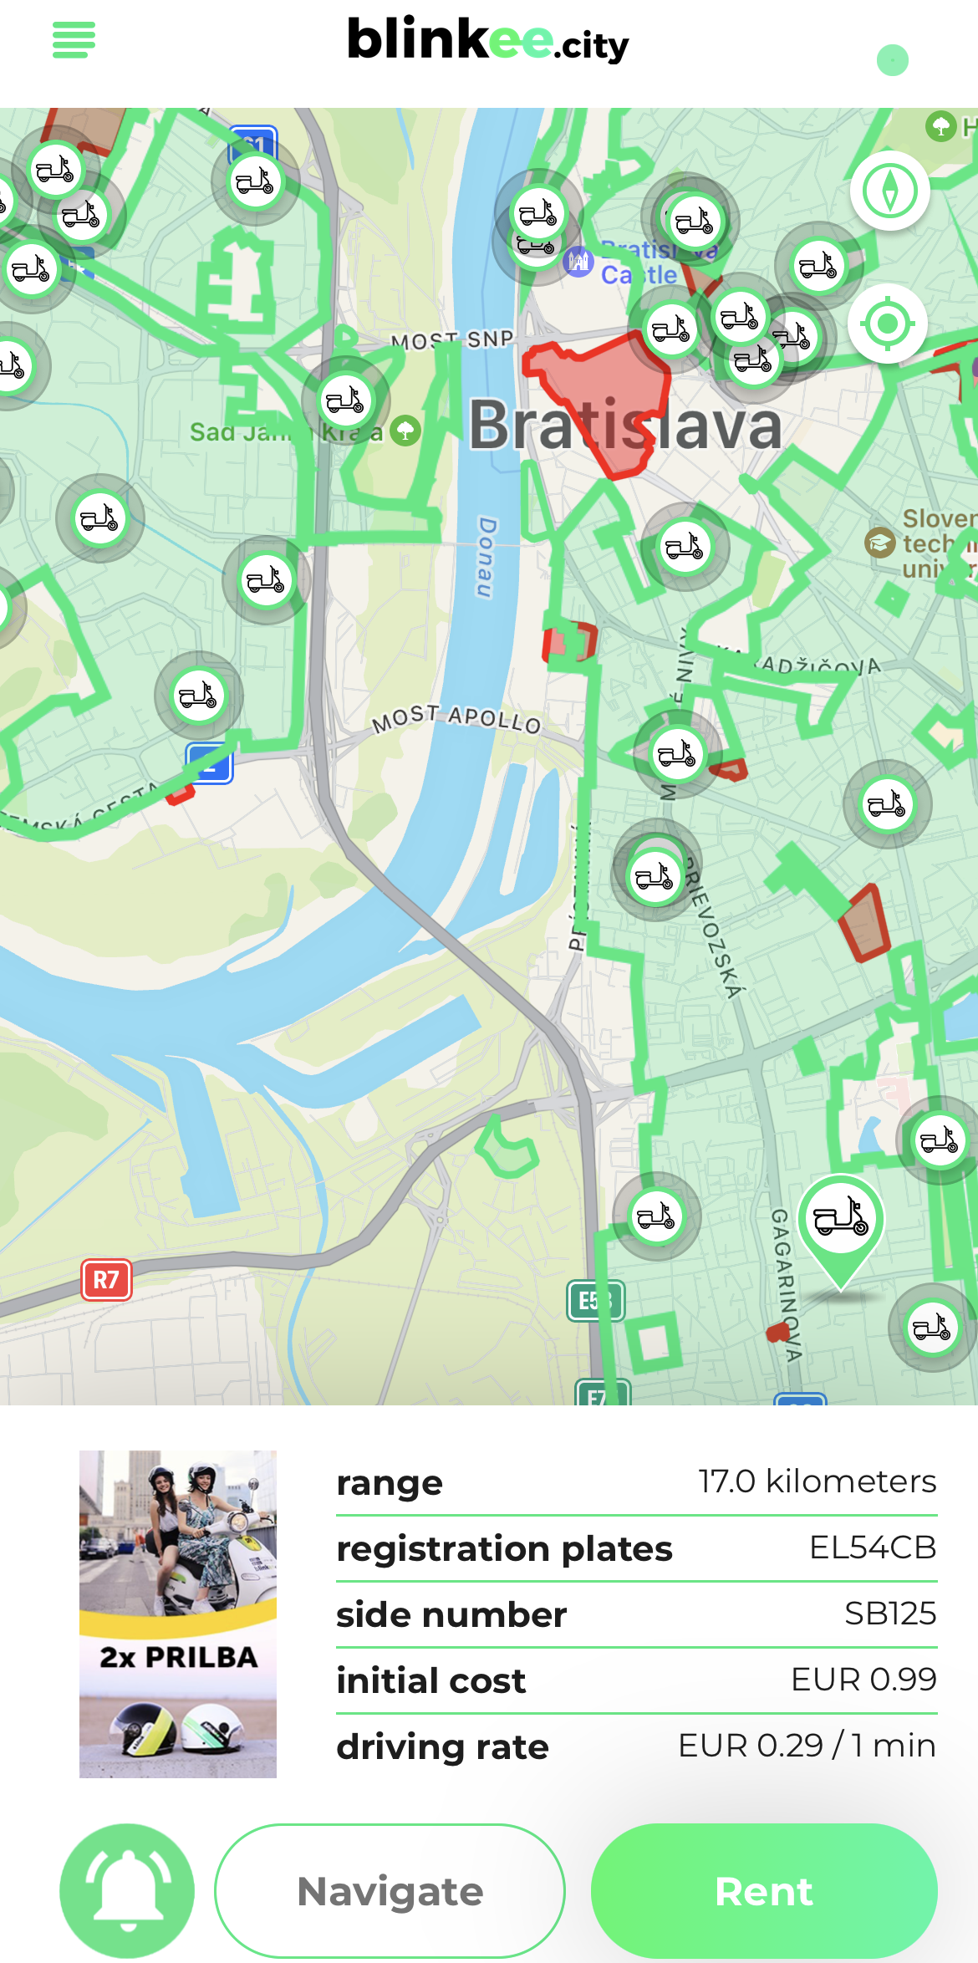

Blinkee offers full electric scooters which you can rent through the app they created. The price is 0.29 €, but you will not pay more than 24 € a day even if you drive the scooter for the whole day.

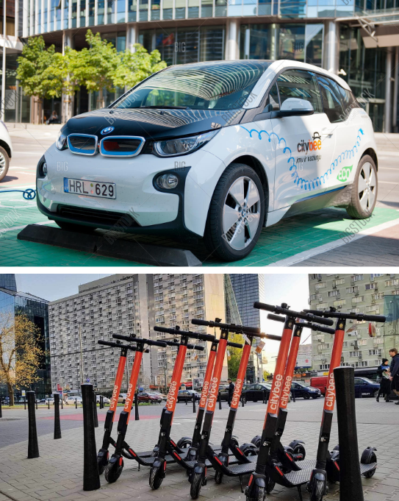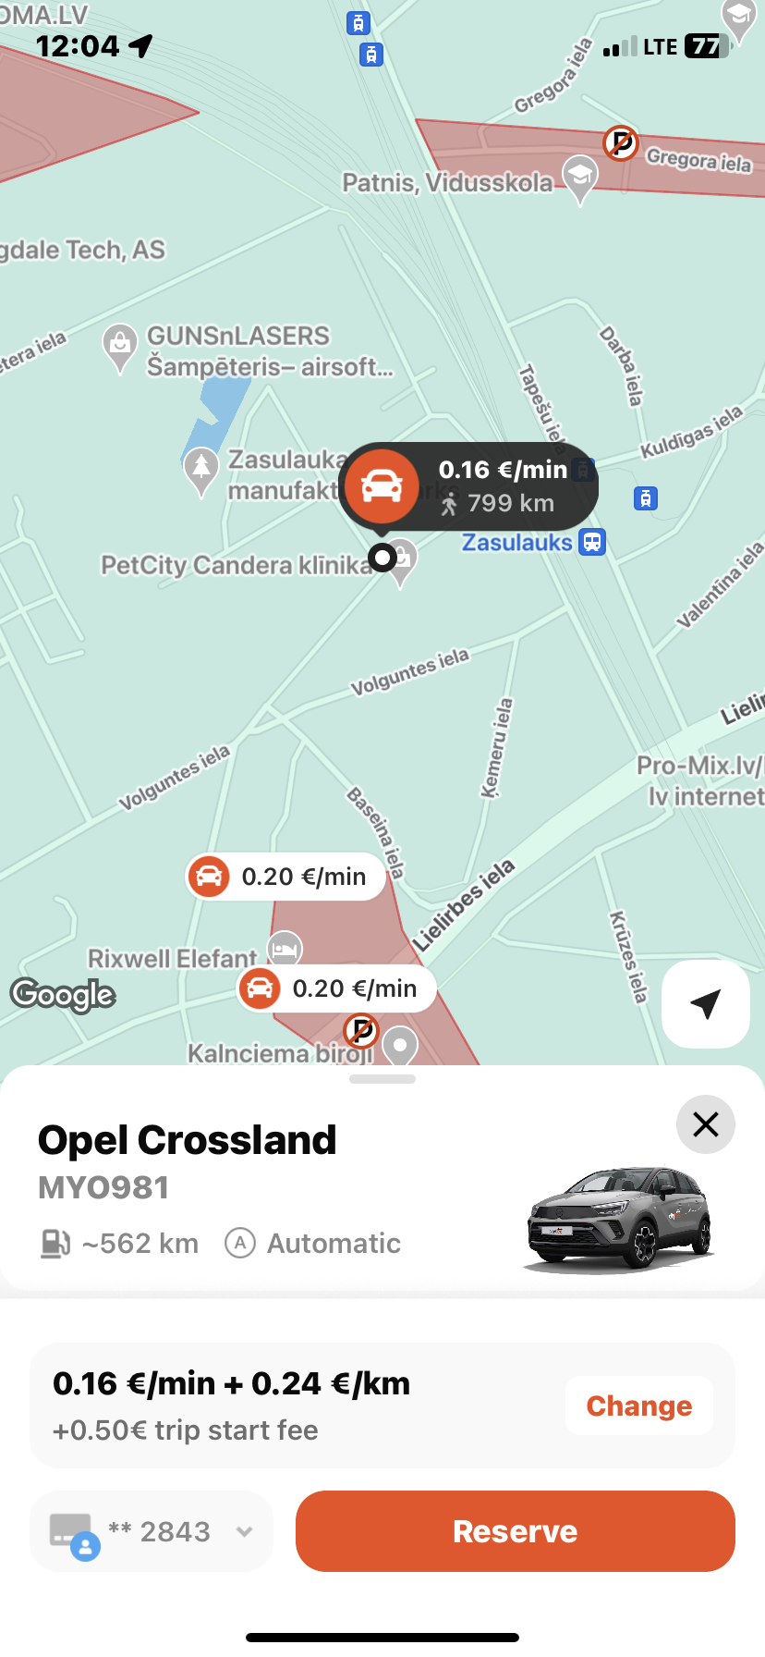

CityBee - electric car sharing company

Blablacar

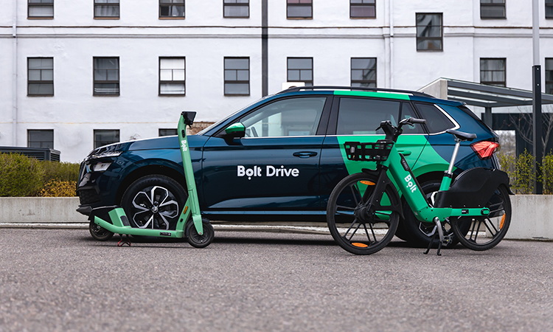

Bolt

Deutsche Bahn (DB) Railway Industry
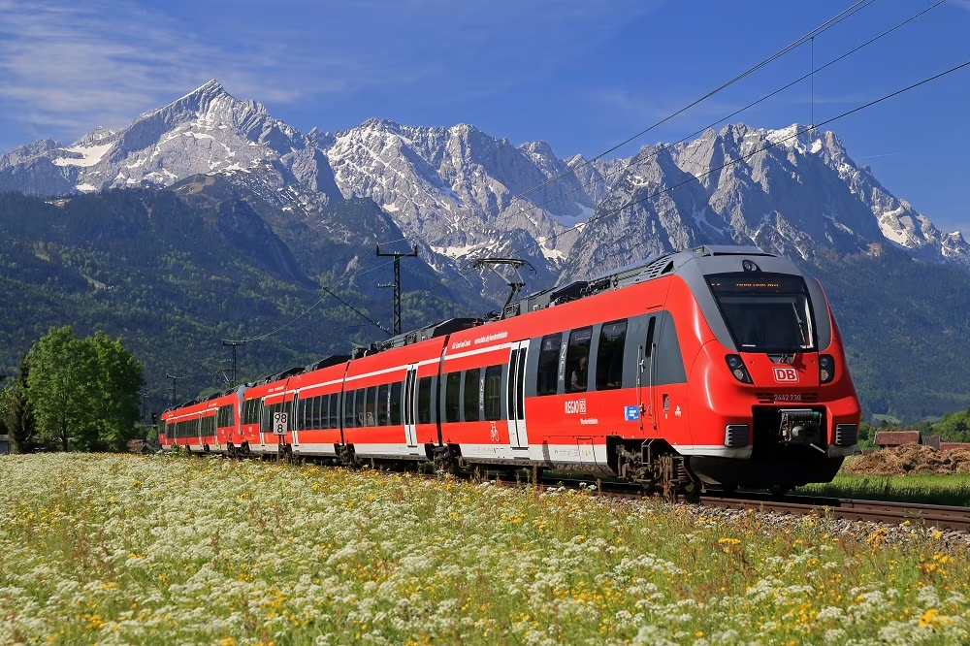

- One of the notable transport industries in Europe that has focused on green transportation is the railway industry.
- Europe has been a leader in promoting and developing rail transportation, which is known for its comparatively lower carbon emissions and energy efficiency.
- One prominent company in the European railway industry that has prioritized green transportation is Deutsche Bahn (DB).

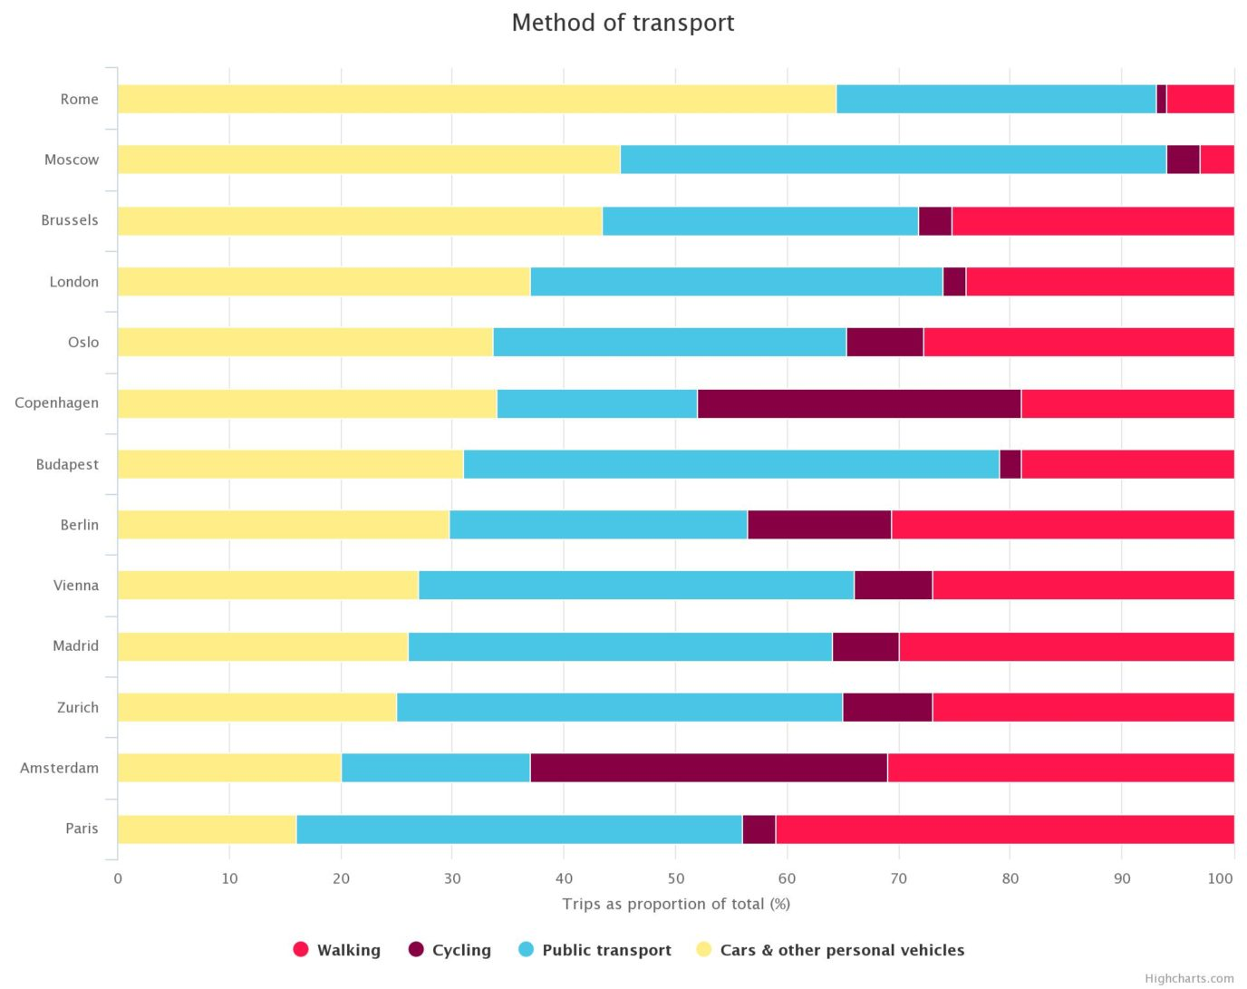
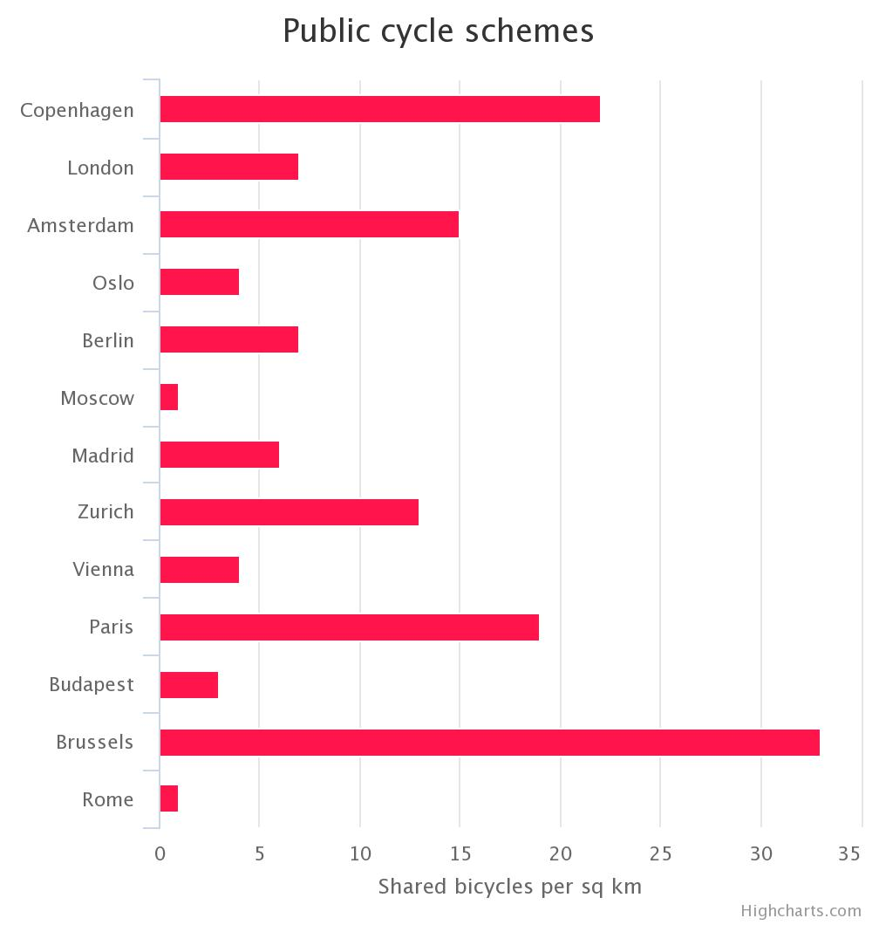

CONCLUSION

Green practices in European cities' transport companies have become vital for achieving sustainable and environmentally friendly transportation systems. These practices align with the broader goals of the European Green Deal. Moreover, the commitment of European transport companies to implement green practices demonstrates their role as catalysts for positive change. By embracing these practices, we can build cleaner, healthier, and more livable cities for current and future generations.

Stowarzyszenie Inicjatyw Kulturalno Młodzieżowych Art
Project: "Switch To a Bike. Protect Your Home"
Program: Erasmus+
Host organization:
Stowarzyszenie Inicjatyw Kulturalno - Młodzieżowych Art
ul: Klikowska 95A, 33-100 Tarnów, Małopolska
KRS: 0000492918 NIP: 9930653729 REGON: 123020154
Partner organisations:
Enterprising Partners (Lithuania)
FNEE - Federação Nacional dos Estudos Europeus (Portugal)
Youth for Experience - Slovakia (YES) (Slovakia)
Silesian Society for Solidarity z.s. (Czech Republic)
Ötszázalék Egyesület (Hungary)
REGIONALAS ATTISTIBAS UN SOCIALO INICIATIVU ORGANIZACIJA PERSPEKTIVA (Latvia)
Place: Poręba Wierzchosławice, Poland
Date: 22-29.05.2023

