Stowarzyszenie Inicjatyw Kulturalno Młodzieżowych Art

"Switch To a Bike. Protect Your Home"

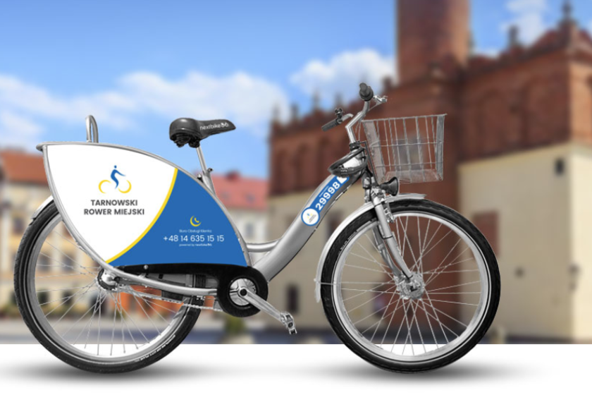

Wierzchosławice 22-29.05.2023
‘’Green practices in EU city transport companies’’

Made by: Latvian team
Linita, Karina, Raimonds, Ralfs
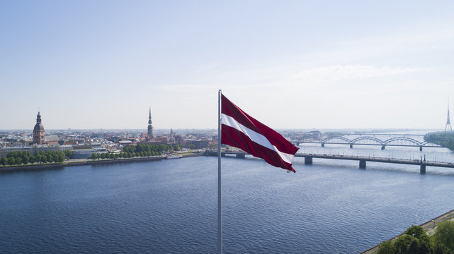
What are green practices?

Green practices are efforts and initiatives to conserve nature, resource and energy

About ‘’Bolt’’

- Estonian mobility company that offers ride-hailing, micromobility rental, food and grocery delivery and car-sharing services

- Founded in 2013 by Marcus Villing

- Operates in over 500 cities in more than 45 countries

- Has more than 100 million customers globally
‘’Bolt’’ sustainability

- E-scooter use is transforming urban environments by reducing CO2 emissions, congestion and pollution

- Scooters complement public transport and help riders go about their daily tasks in a more sustainable way

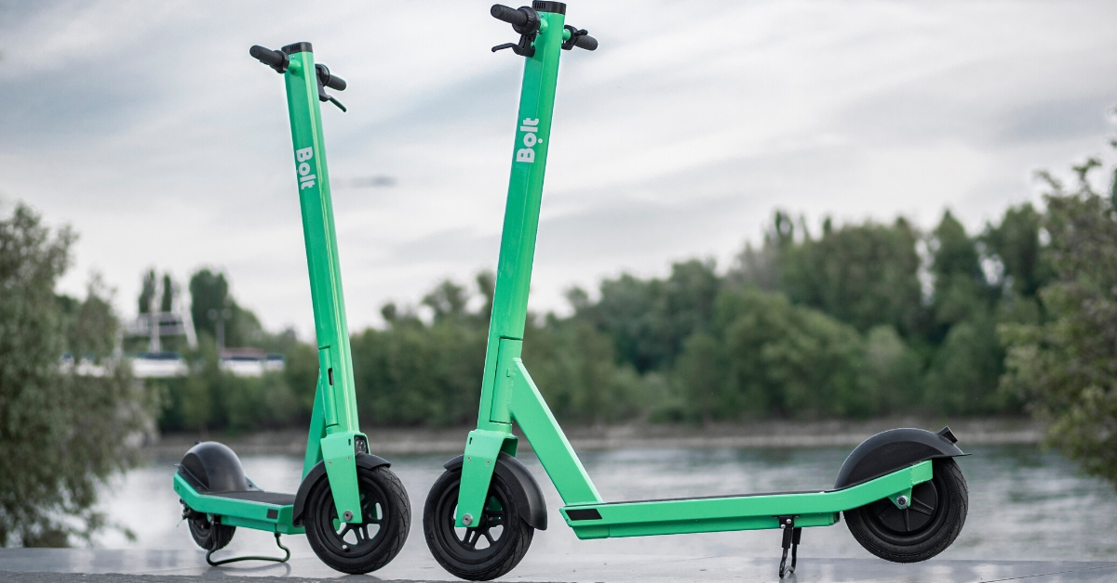

Carbon footprint

- In partnership with Seedballs Kenya they have planted over 11 million tree seeds to reforest degraded areas in Kenya

- Those trees will compensate the carbon footprint of Bolt rides and Bolt food

About ‘’ Škoda’’

- Czech manufacturer established in 1925

- Škoda products are sold in over 100 countries

- Škoda Group focuses on the production of public transport and railway vehicles
‘’Škoda’’ 16Ev train

- Škoda Group will deliver 32 fully passenger-ready electric trains to Latvia by the end of 2023, each consisting of four carriages. One electric train will be 109 metres long and have 436 seats

- The new trains will significantly improve passenger rail services and strengthen the railway as the backbone of public transport
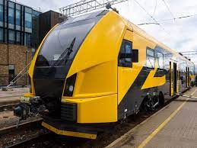
About ‘’Rigas Satiksme’’

- Municipally-owned public transportation and infrastructure company serving Riga, Latvia and the surrounding areas

- Founded on 20 February 2003

- It currently employs roughly 4,100 staff and its passengers completed 146.8 million rides
Riga trolleybus

- Rīga public transport uses Solaris electric trolleybuses that have hydrogen range extender

- Hydrogen electric vehicles can be filled up in 7-10 minutes and they can cover 300-400 km with one filling

- Rigas satiksme has ordered 35 new electric trolleybuses, which will arrive in the end of 2023

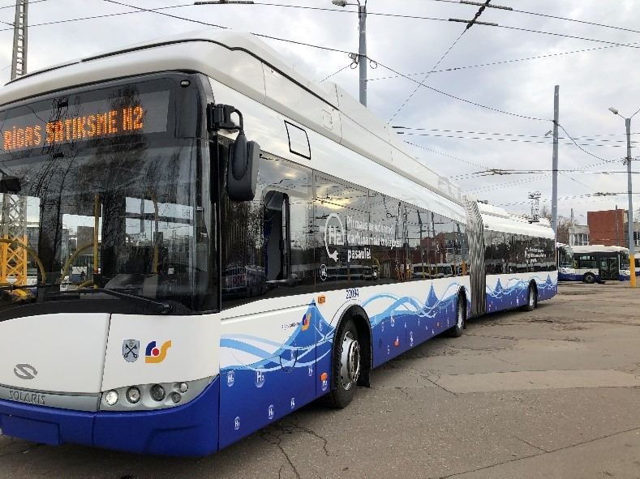

Thank you for your attention!
Do you have any questions?

Stowarzyszenie Inicjatyw Kulturalno Młodzieżowych Art

Project: "Switch To a Bike. Protect Your Home"
Program: Erasmus+

Host organization:
Stowarzyszenie Inicjatyw Kulturalno - Młodzieżowych Art
ul: Klikowska 95A, 33-100 Tarnów, Małopolska
KRS: 0000492918 NIP: 9930653729 REGON: 123020154

Partner organisations:
Enterprising Partners (Lithuania)
FNEE - Federação Nacional dos Estudos Europeus (Portugal)
Youth for Experience - Slovakia (YES) (Slovakia)
Silesian Society for Solidarity z.s. (Czech Republic)
Ötszázalék Egyesület (Hungary)
REGIONALAS ATTISTIBAS UN SOCIALO INICIATIVU ORGANIZACIJA PERSPEKTIVA (Latvia)

Place: Poręba Wierzchosławice, Poland
Date: 22-29.05.2023

