Stowarzyszenie Inicjatyw Kulturalno Młodzieżowych Art

"Switch To a Bike. Protect Your Home"

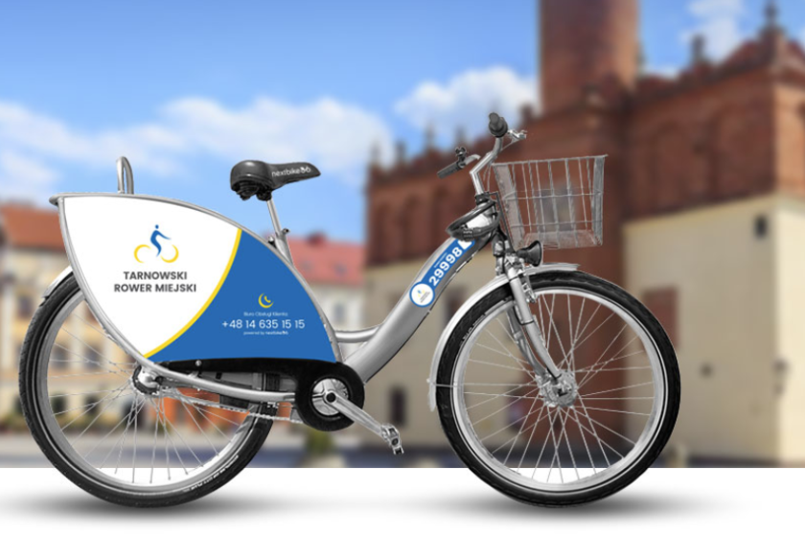

Wierzchosławice 22-29.05.2023

Introduction

Green practices in European city transport companies focus on reducing emissions, improving air quality, and promoting sustainable transportation. They involve initiatives like electric and hybrid vehicles, renewable energy sources, cycling promotion, and efficient public transport. These practices contribute to creating cleaner and greener urban environments while addressing climate change challenges.

Electric and Hybrid vehicles

Europe is the second-largest market for electric and hybrid vehicles. Norway has the highest market share of electric vehicles, followed by Iceland and Sweden. Mercedes and Wolkswagen are the top brands in EV sales in Europe as of Q3 2022.

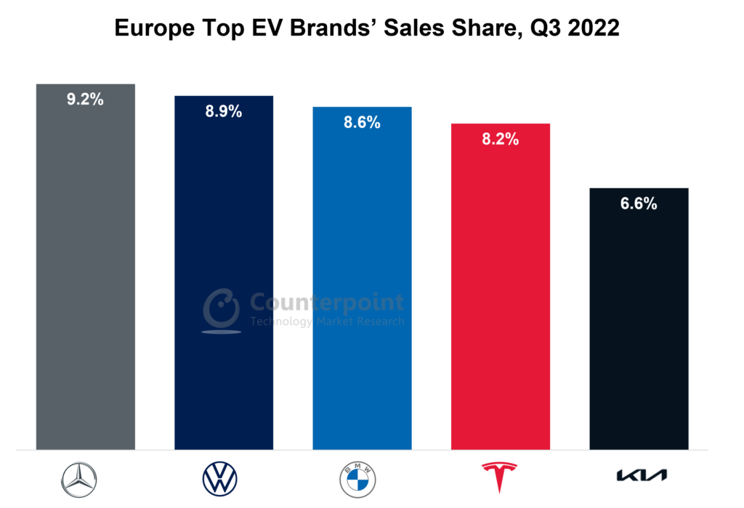

Benefits of EV and HVs:

Electric and hybrid vehicles have several benefits over traditional gasoline vehicles. Some of them are as follows:

- Environmental friendly
- Produce less noise pollution
- Cheaper to operate
- Eligible for government incentives and tax credits
- Lower maintenance costs
- Smoother driving experience

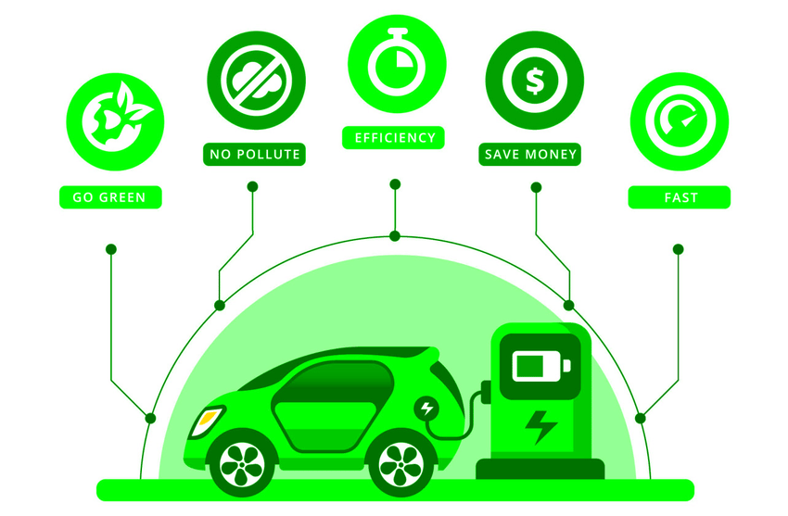

Challenges of EV and HVs:

Despite the benefits, there are also challenges associated with electric and hybrid vehicles.

- High upfront cost
- Unlimited range of electric vehicles
- Lack of charging infrastructure
- Longer charging time

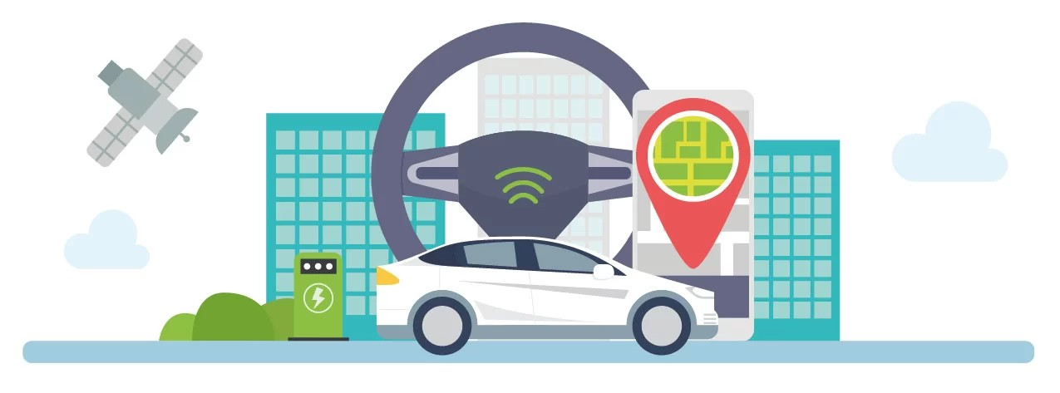

Future of Electric and Hybrid vehicles:

The future of electric and hybrid vehicles looks promising. The European Union has set a target to reduce emissions by 40% by 203. Many countries are also setting targets to ban gasoline and diesel vehicles in the coming years. The advancements in battery technology and the development of fast-charging infrastructure are also contributing to the growth of the industry.

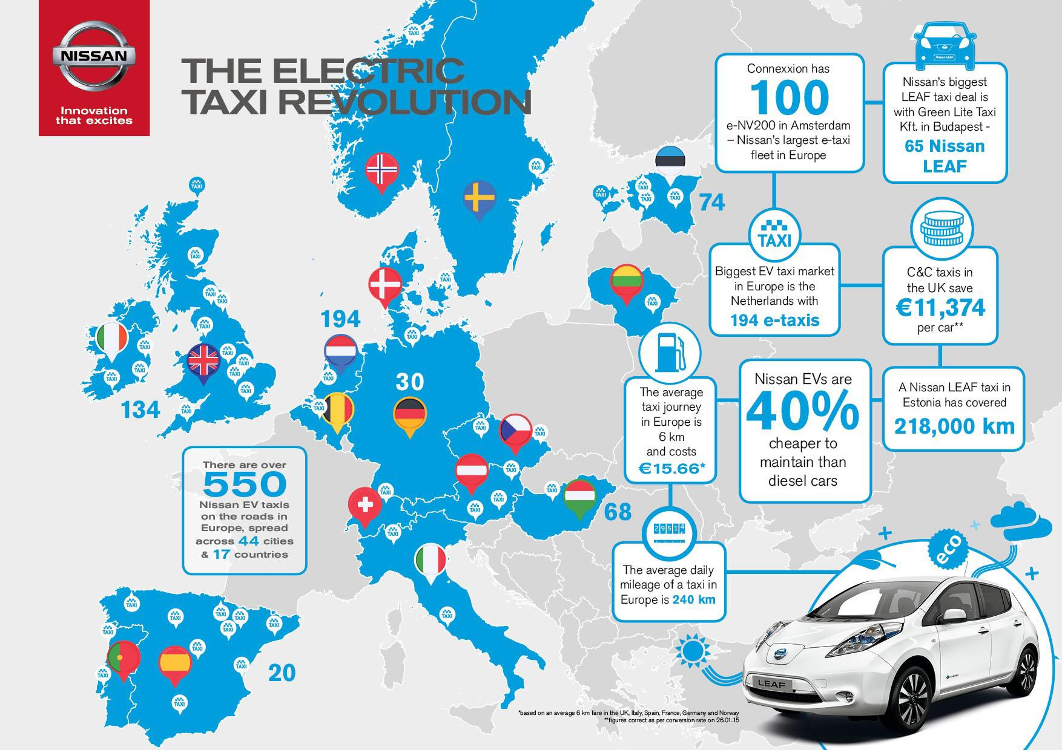

Renewable Energy Sources:

Renewable energy sources are increasingly powering city transportation in Europe. Here are some examples:
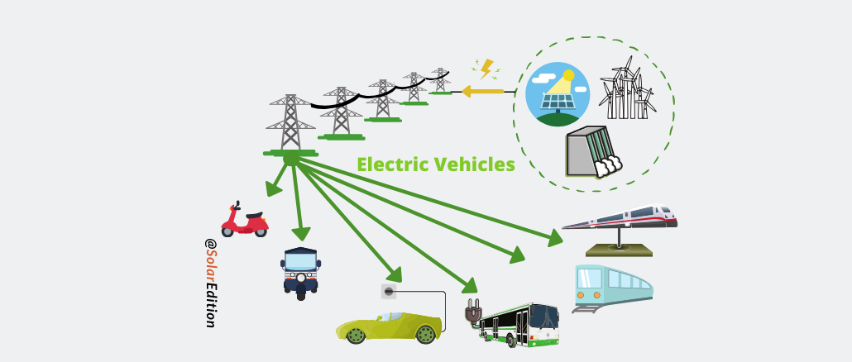

- Electric Vehicles (EVs): Electric cars, buses, and bicycles are gaining popularity. They are charged using renewable sources like solar, wind, and hydro power.

- Solar Power: Solar panels installed on buildings and roads capture sunlight and provide energy for electric transportation. Solar-powered charging stations support EVs.

- Wind Power: Wind turbines generate electricity, directly powering electric trains, trams, and indirectly supporting EVs.

- Biomass: Organic matter is converted into energy. Cities use biofuels like biogas or bioethanol for public transportation fleets.

- Hydroelectric Power: Water energy powers public transportation systems like trams and trains, indirectly supporting electric vehicles.

- Geothermal Energy: Underutilized but has potential for future transportation systems.

Europe is embracing these renewable energy sources, but a comprehensive approach involving infrastructure, policies, and public participation is crucial for sustainable transportation.

Energy efficiency measures in transportation

Europe is implementing energy efficiency measures in transportation, including:

- Fuel efficiency standards for vehicles.
- Promotion of efficient public transportation systems.
- Modal shift towards walking, cycling, and public transit.
- Intelligent transportation systems to optimize traffic flow.
- Eco-driving practices and driver training.
- Infrastructure optimization for smoother traffic.
- Eco-friendly freight transport using cleaner fuels and logistics optimization.

Public bicycles systems
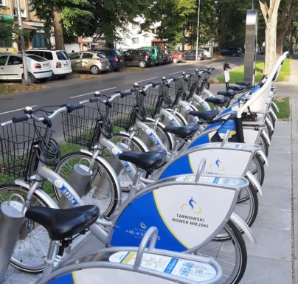

Known also as Public-use Bicycles (PUB’s), bike sharing or smart bikes, bike sharing schemes (BSS) are short-term urban bicycle rental schemes that enable bicycles to be picked up at any self-serve bicycle station and returned to any other bicycle station, which makes bicycle-sharing ideal for point-to-point trips. These bicycles are available for shared use by individuals at low cost.
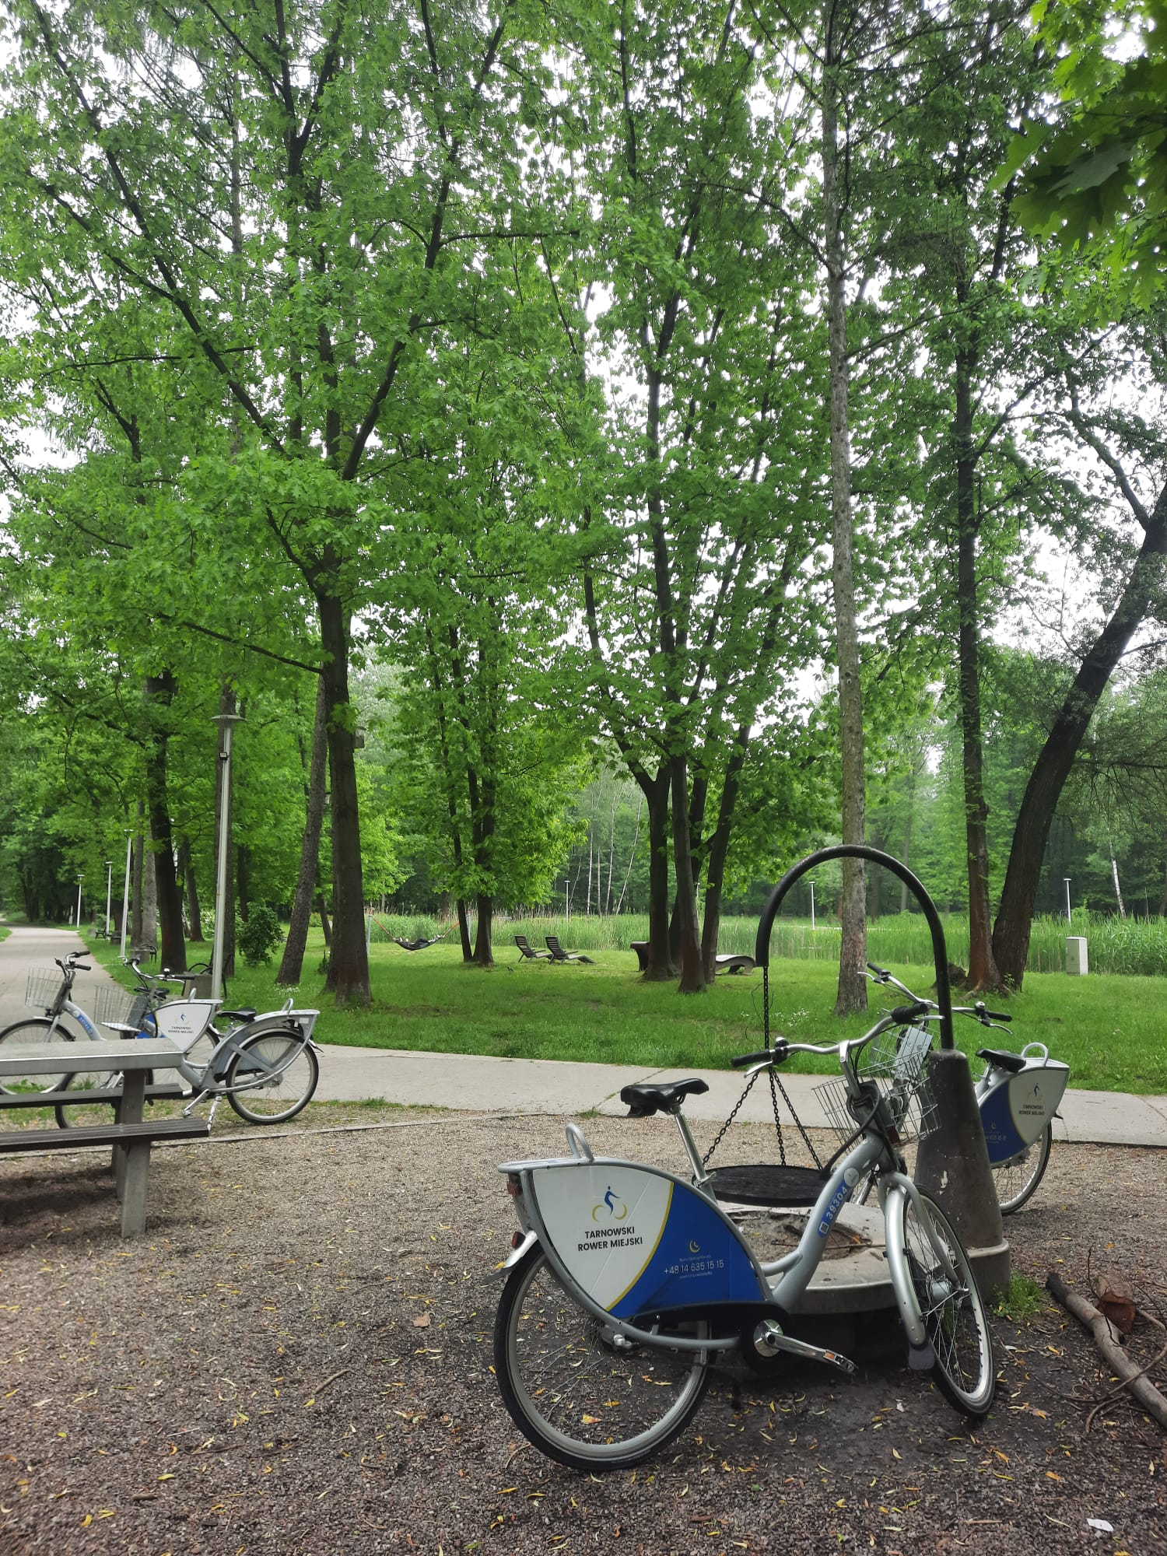

Which European city is known for its bicycle infrastructure?

Amsterdam, Netherlands

Battling it out with Copenhagen, Amsterdam is arguably the most famous cycling city in the world. There are about 880,000 bicycles in a city of 800,000 people, and 58% of locals older than 12 cycle daily.07/04/2023

Carpooling and ride-sharing
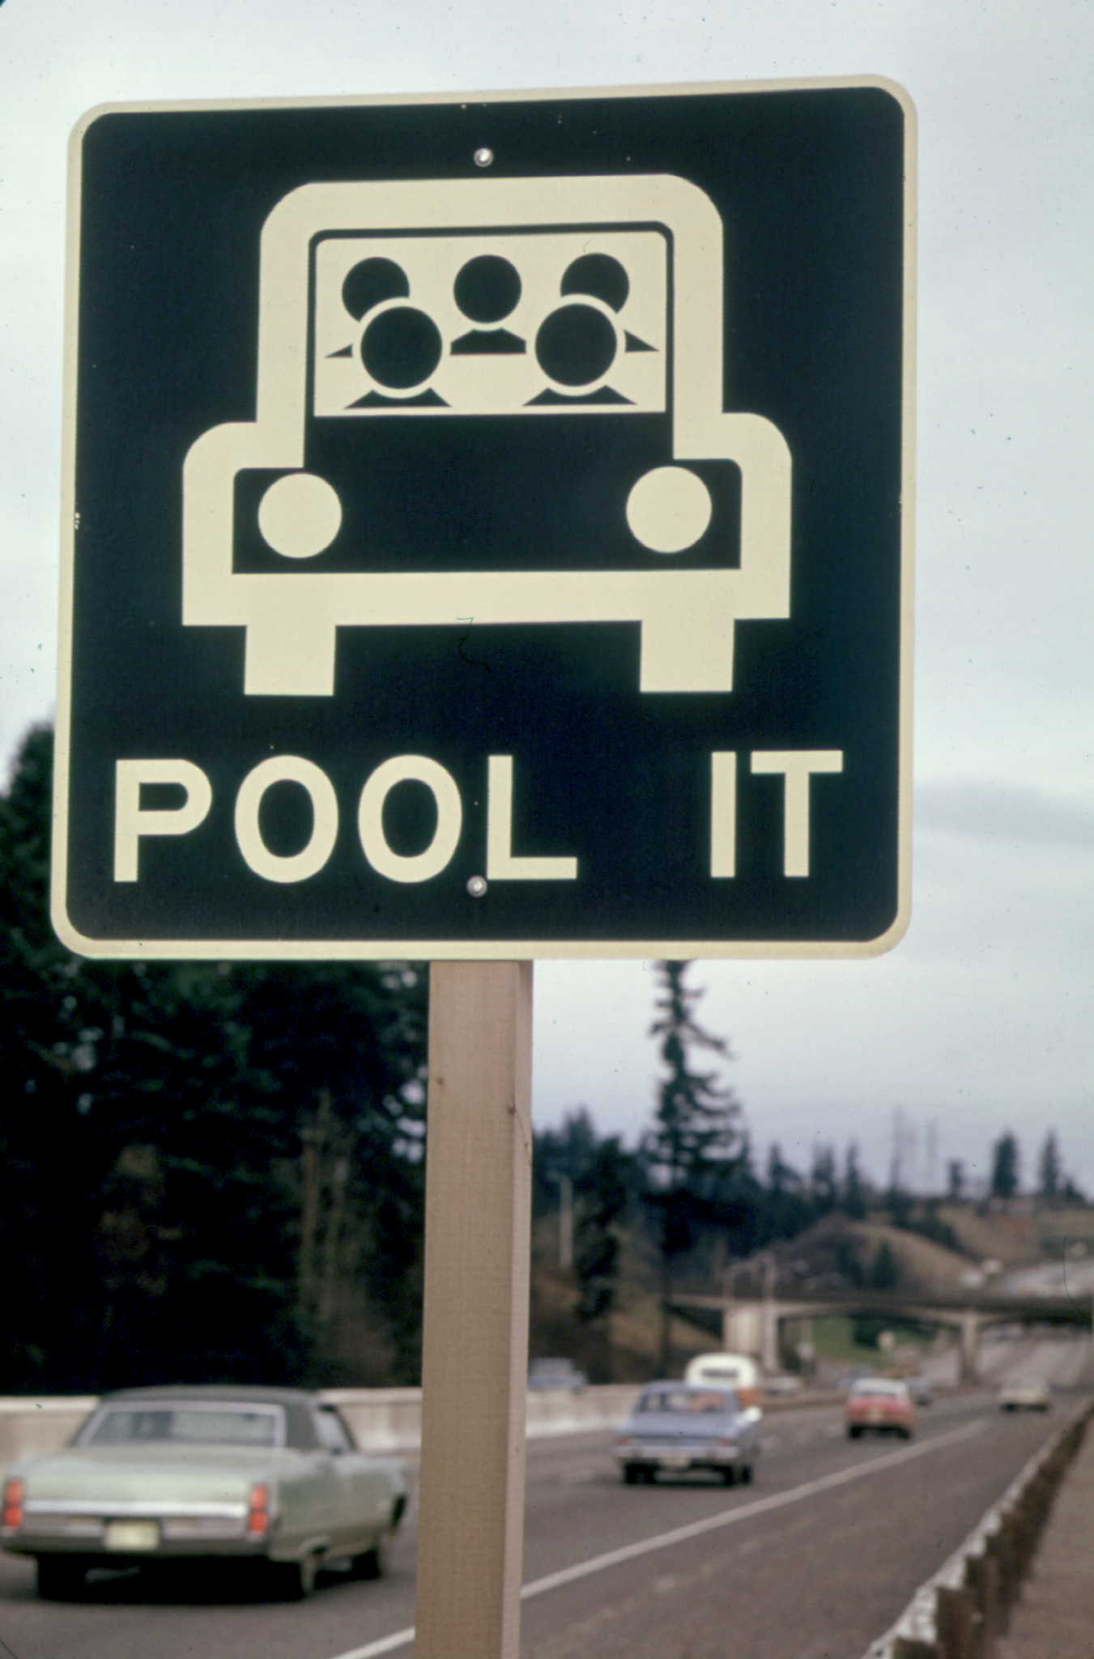

Why is it called carpooling?

Ridesharing began during World War II through “car clubs” or “car-sharing clubs”. The US Office of Civilian Defense asked neighborhood councils to encourage four workers to share a ride in one car to conserve rubber for the war effort.

Carpooling is an arrangement in which drivers of usually privately owned vehicles who wish to offer rides and passengers who wish to obtain rides use a network (such as one accessed through an app or a website) to coordinate the sharing of individual automobile trips for which the passengers pay a fare.
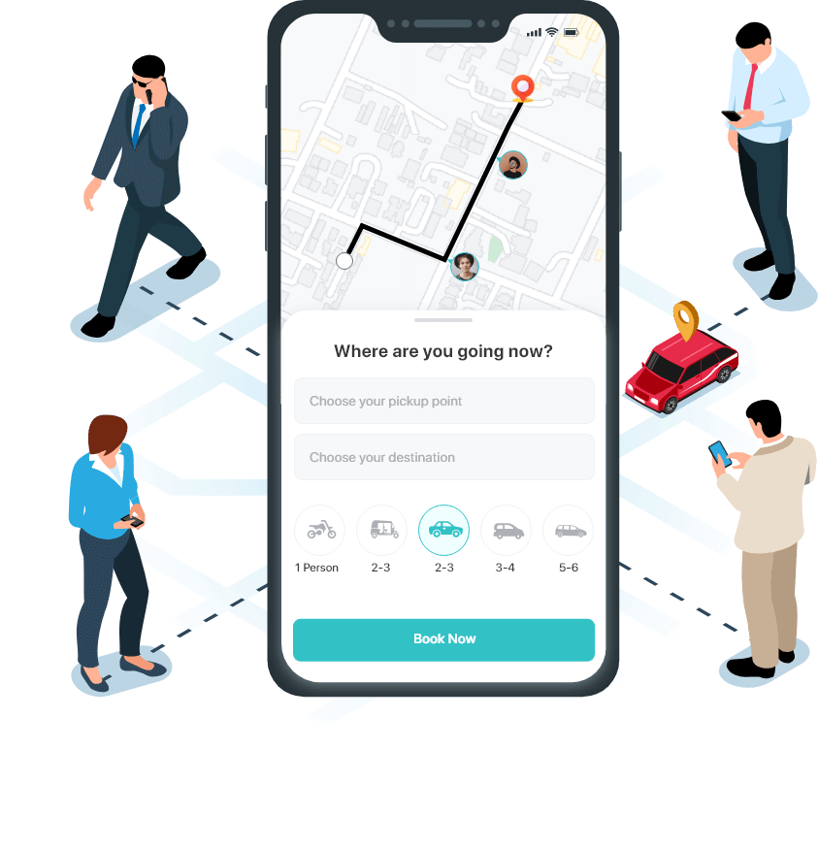

What is the difference between carpooling and ride-sharing?

Carsharing is a form of shared vehicle ownership to provide members with vehicles for personal use without the costs and commitment of individual car ownership. Ridesharing, also called carpooling, can reduce travel costs, traffic, and parking demand.
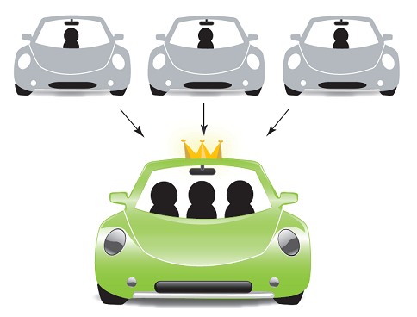

Integration of differents modes of transports

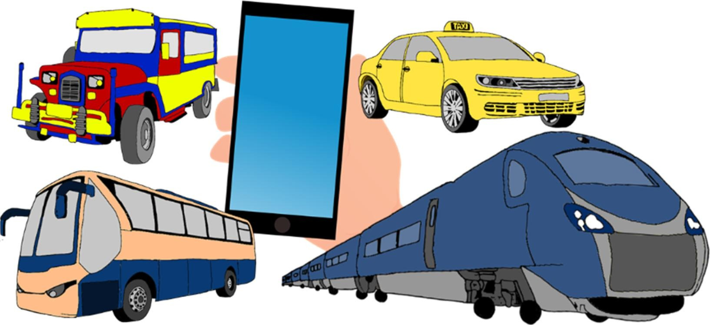
Integrated transport involves the combining of different modes of transport to maximize ease and efficiency for the user in terms of time, cost, comfort, safety, accessibility and convenience. Different modes of transport have differing technical and operational capabilities.
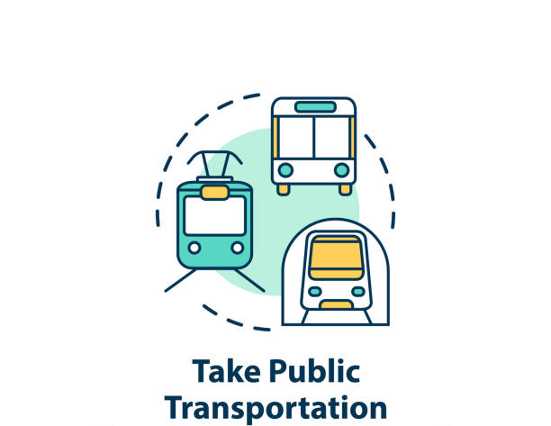

Multimodal integration refers to the steps taken to enable the use of one or modes of transport (including cycling) to increase access to destinations and to provide an alternative to the use of the private car.

Collective Innovation for Public Transport in European Cities
SOCIETAL CHALLENGES - Smart, Green And Integrated Transport
It was a project, started May 1, 2015 and ended April 20, 2018, in which the specific objective is to achieve a European transport system that is resource-efficient, climate- and environmentally-friendly, safe and seamless for the benefit of all citizens, the economy and society.
Europe must reconcile the growing mobility needs of its citizens and goods and the changing needs shaped by new demographic and societal challenges with the imperatives of economic performance and the requirements of an energy-efficient low-carbon society and climate-resilient economy. Despite its growth, the transport sector must achieve a substantial reduction in greenhouse gases and other adverse environmental impacts, and must break its dependency on oil and other fossil fuels, while maintaining high levels of efficiency and mobility and promoting territorial cohesion.

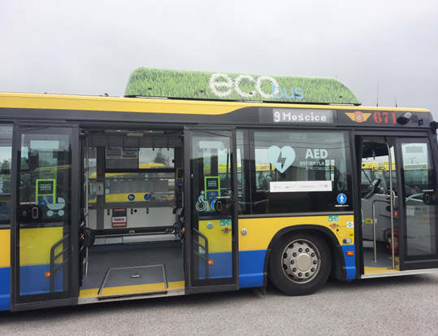
a) Resource-efficient transport that respects the environment

The aim is to minimize transport systems' impact on climate and the environment (including noise and air pollution) by improving their quality and efficiency in the use of natural resources and fuel, and by reducing greenhouse gas emissions and dependence on fossil fuels.

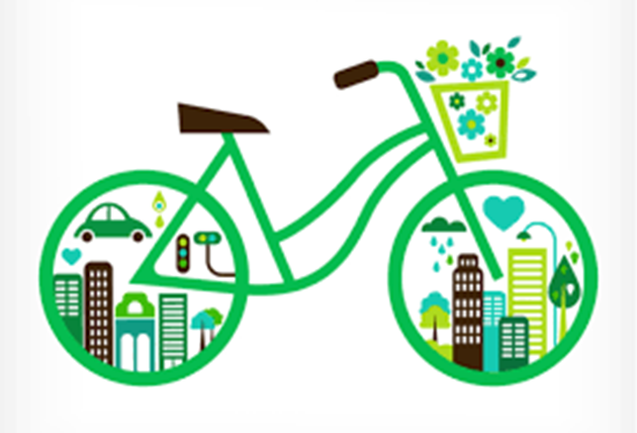
(b) Better mobility, less congestion, more safety and security
The aim is to reconcile the growing mobility needs with improved transport fluidity, through innovative solutions for seamless, intermodal, inclusive, accessible, affordable, safe, secure, healthy, and robust transport systems.
The focus of activities shall be to reduce congestion, improve accessibility, interoperability and passenger choices, and to match user needs by developing and promoting integrated door-to-door transport, mobility management and logistics; to enhance intermodality and the deployment of smart planning and management solutions;

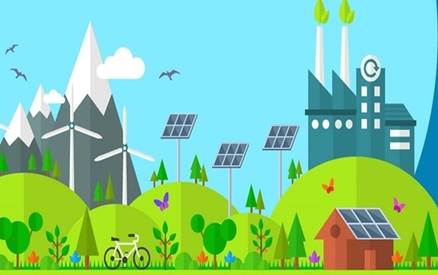
c) Global leadership for the European transport industry
The aim is to reinforce the competitiveness and performance of European transport manufacturing industries and related services (including logistic processes, maintenance, repair, retrofitting and recycling) while retaining areas of European leadership (e.g. aeronautics).
The focus of activities shall be to develop the next generation of innovative air, waterborne and land transport means, ensure sustainable manufacturing of innovative systems and equipment and to prepare the ground for future transport means.

Emission Monitoring and Reporting

- Systematic measurement, tracking and reporting of emissions in city transport operations
- Utilizes onboard systems, sensors, and telematics for real-time data collection.
- Enables calculation of emissions and identification of trends for optimization.
- Supports transparency, compliance, and continuous improvement.
- Practiced in cities such as Amsterdam, London, Stockholm, Copenhagen, Helsinki, Berlin, Oslo, Barcelona, Vienna
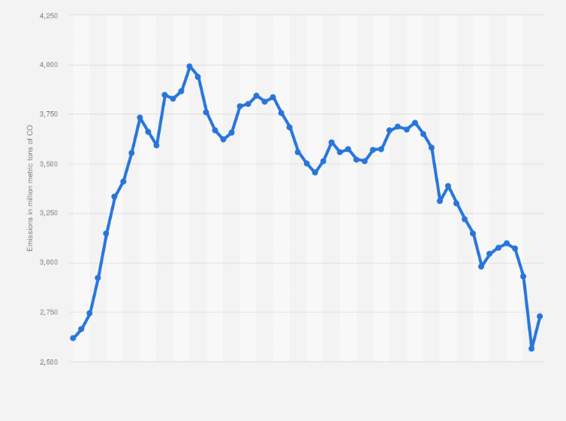

Low-Emission Zones and Traffic Restrictions
- Low-Emission Zones: These are designated areas within cities where access is restricted or regulated based on vehicle emissions. Only vehicles that meet specific emission standards are allowed to enter.
- Examples of European cities with Low-Emission Zones
London, United Kingdom: London has implemented a Low-Emission Zone to tackle air pollution, requiring vehicles to meet certain emission standards to enter the city center.
Berlin, Germany: Berlin has established an environmental zone where only vehicles meeting specific emission requirements, such as Euro standards, can enter.
Madrid, Spain: Madrid has implemented a Central Madrid Low-Emission Zone, restricting access to certain vehicles based on their emissions.
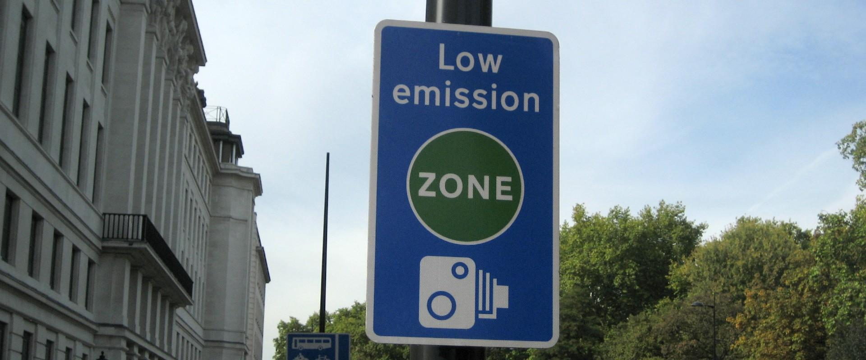

- Traffic Restrictions: These measures involve implementing restrictions on certain vehicles or traffic types to reduce congestion and emissions in specific areas or during particular times.
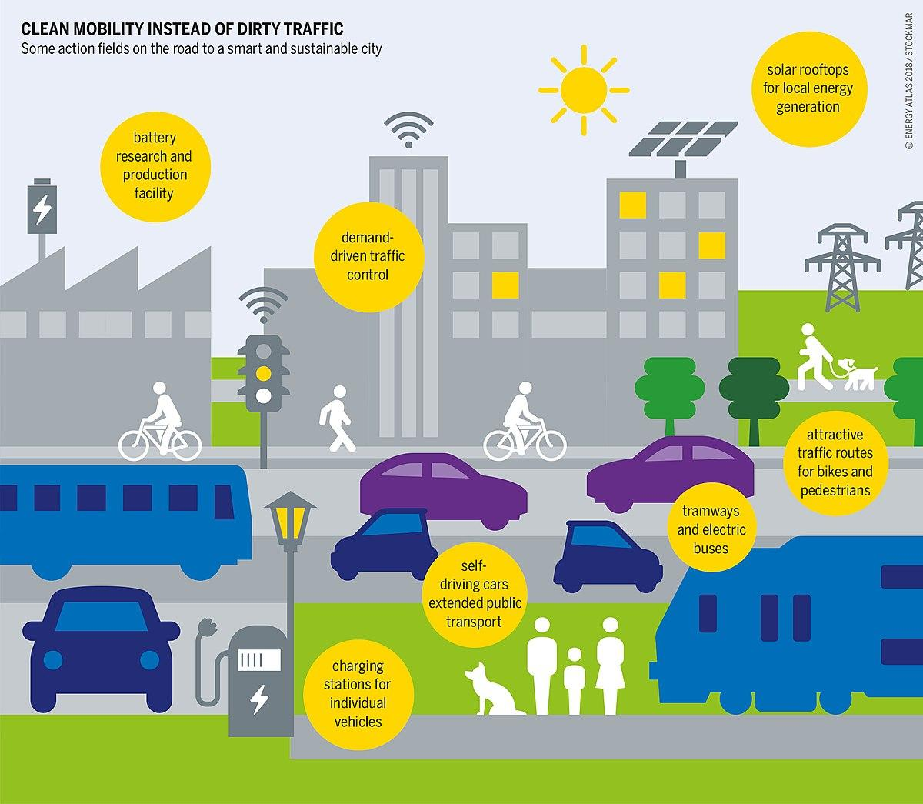
- Examples of European cities with Traffic Restrictions:
Rome, Italy: Rome has implemented traffic restrictions known as "Ecopass" to limit the entry of high-polluting vehicles into the city center during certain hours.
Athens, Greece: Athens has implemented traffic restrictions, including car-free days and traffic bans for specific vehicle types, to address air pollution and congestion
Stockholm, Sweden: Stockholm has introduced congestion charges, levied during peak hours in the city center, to discourage car use and reduce traffic congestion.

Conclusion

European city transport companies are implementing green practices such as electric vehicles, renewable energy, cycling promotion, and efficient public transport. These initiatives reduce emissions, enhance air quality, and promote sustainability. This contributes to creating cleaner, greener cities and a more sustainable future.

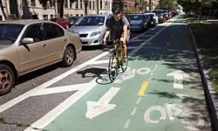

Stowarzyszenie Inicjatyw Kulturalno Młodzieżowych Art

Project: "Switch To a Bike. Protect Your Home"
Program: Erasmus+

Host organization:
Stowarzyszenie Inicjatyw Kulturalno - Młodzieżowych Art
ul: Klikowska 95A, 33-100 Tarnów, Małopolska
KRS: 0000492918 NIP: 9930653729 REGON: 123020154

Partner organisations:
Enterprising Partners (Lithuania)
FNEE - Federação Nacional dos Estudos Europeus (Portugal)
Youth for Experience - Slovakia (YES) (Slovakia)
Silesian Society for Solidarity z.s. (Czech Republic)
Ötszázalék Egyesület (Hungary)
REGIONALAS ATTISTIBAS UN SOCIALO INICIATIVU ORGANIZACIJA PERSPEKTIVA (Latvia)

Place: Poręba Wierzchosławice, Poland
Date: 22-29.05.2023

